DevOps Project Screenshots

Abdallah Kazi 2312226

Health
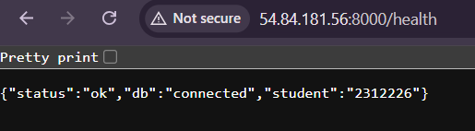

API Docs
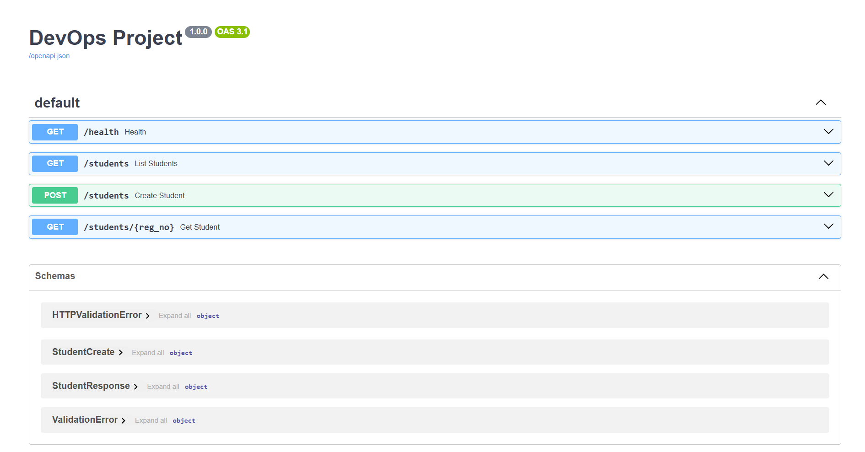

CI/CD workflows
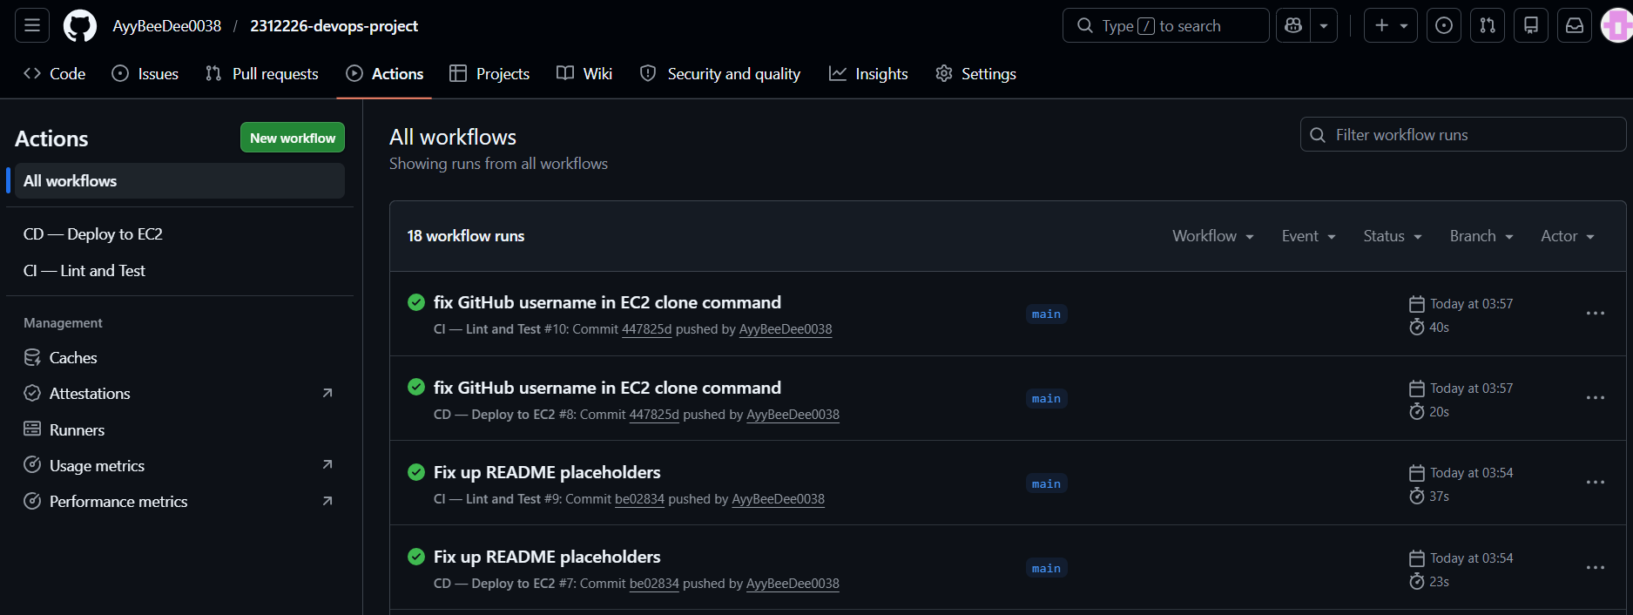

Merges
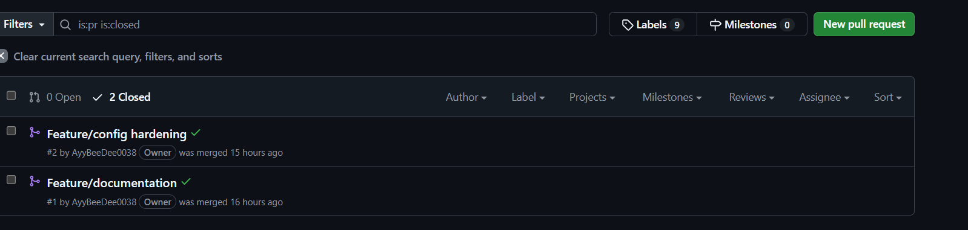

Commits
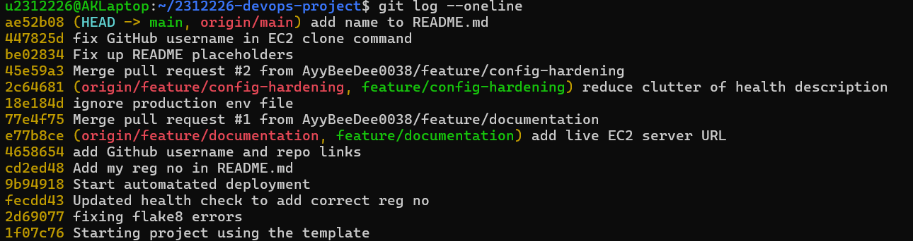

README.md
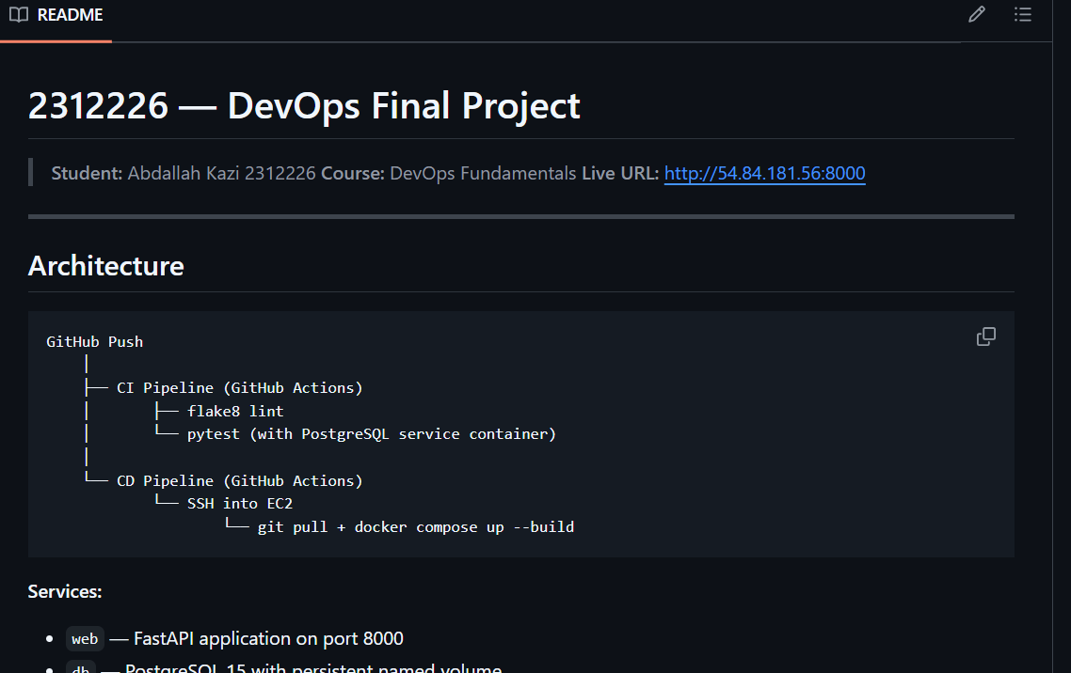

Containers in EC2 instance

